Skill Week 7
Aim
To practice input redirection in Linux by creating an input file and using it as input for a command.

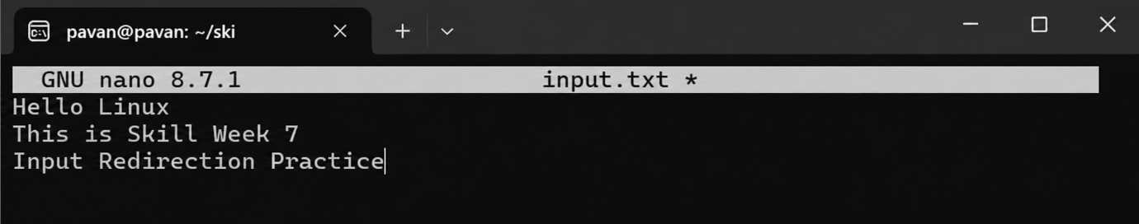
Output:
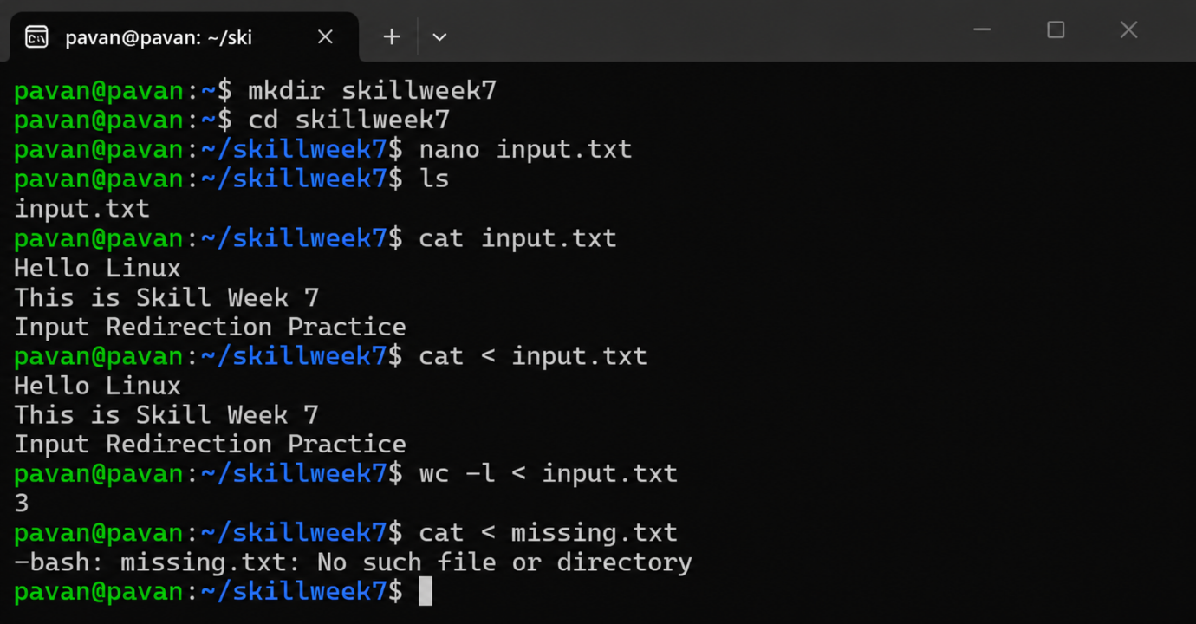
Observation:
Linux displays an error because missing.txt does not exist.
Result:
Successfully tested how Linux handles input redirection when the specified file is missing.

Aim
To learn how to redirect the output of a Linux command into a file and then view the saved output.
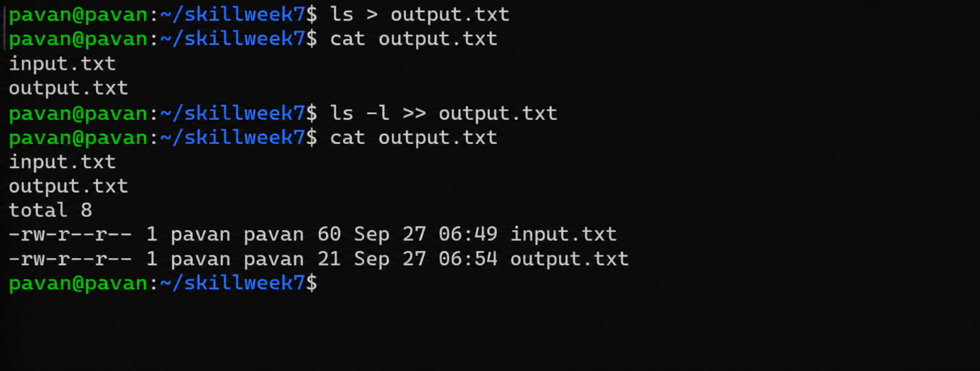
Observation:
The >> operator successfully appended new command output to the existing output.txt file.
Result:
Output redirection and output appending were successfully performed.
Aim
To understand the append operator >>, open a file in append mode, preserve existing data, and verify that new data is added without overwriting the old data.
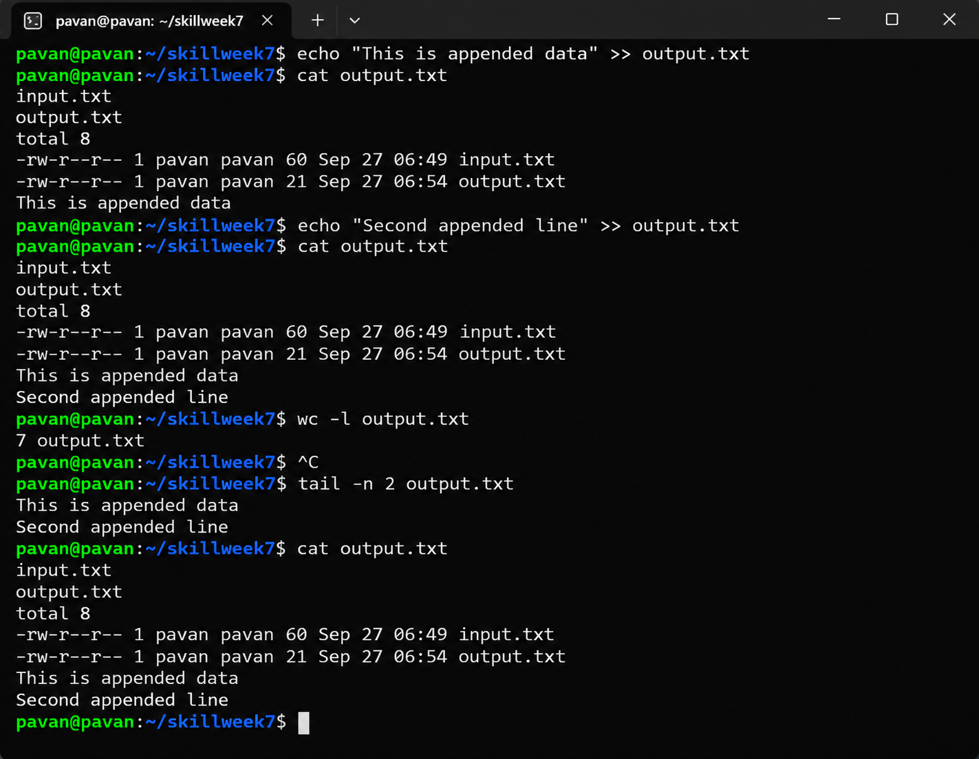
Aim
To understand standard error (stderr) redirection in Linux and redirect error messages from the terminal into a file.
